REVISION

PHONETICS
I. Put the words into the correct column depending on how the ending –ed is pronounced.
Pulled, opened, closed, featured, decided, showed, danced, saved, suggested, walked, enjoyed, needed, watched, attended, waited, finished, hated, painted, stopped, ended, engaged, laughed, performed, wanted, looked, cried, directed, relaxed, described, increased, brushed, touched
/t/ | /d/ | /id/
II. Find the word which has the different sound in the underlined part.
1. a. break b. bread c. instead d. health
2. a. lane b. stay c. traffic d. wait
3. a. record b. vehicle c. lesson d. zebra
4. a. jam b. narrow c. carry d. danger
5. a. means b. great c. seatbelt d. teacher
VOCABULARY AND GRAMMAR

I. Write the means of transport under the correct pictures
bike plane truck train ship motorbike car boat bus subway helicopter van

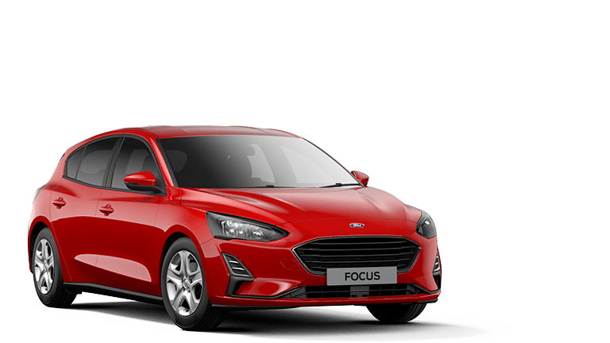  1………………… | 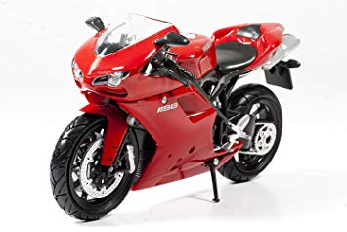  2………………. | 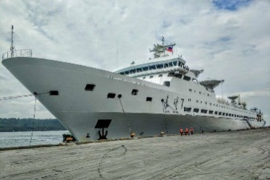  3……………….
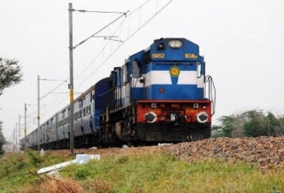  4…………………. | 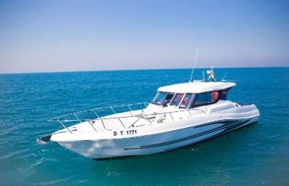  5………………… | 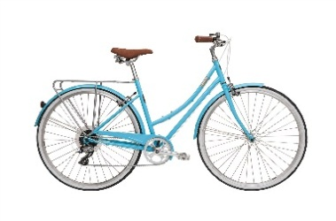  6…………………
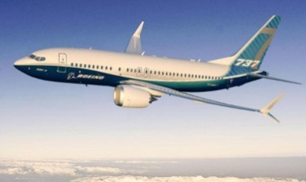  7……………….. | 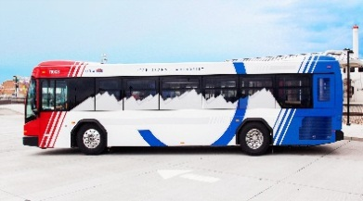  8………………….. | 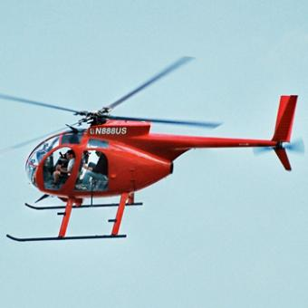  9……………….
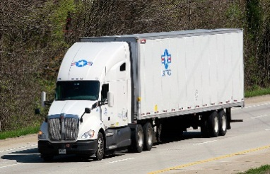  10……………… | 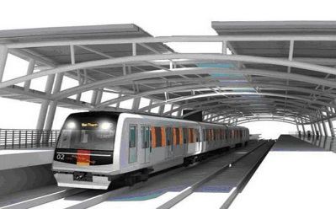  11……………….. | 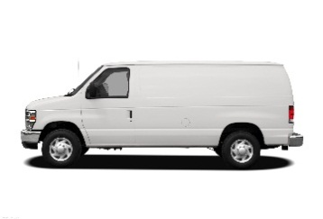  12………………..
II. Complete the sentences with the correct tense or form of the verbs from the box.
ride drive fly sail cycle reverse get on get off

1. My uncle used to be a pilot. He ___________ helicopters.
2. __________ a number 73 bus. That will take you to Islington High Street.
3. He ________into a lamppost and damaged the back of the car.
4. When being stuck in a traffic jam, some people __________ their motorbikes on the pavement.
5. The old man got into a Rolls Royce and __________ away.
6. I will get myself a little boat and ________ it around the world.
7. When we reach the next stop, we’ll ____________.
8. In the afternoon, Mai usually _____________ round the lake near her house
III. Fill in the each gap with an expression in the box.
plane tickets zebra crossings driving licence traffic jam speed limit
cycle helmet means of transport road safety railway station road sign

1. Be careful! The _____________ says “No U-Turn”.
2. You ran through the stop sign. May I see your ________________, please?
3. It is the law that motorists give way to pedestrians at _______________.
4. You can book your _______________ online, by phone, or through a travel agent.
5. Slow down – the _______________ on this road is 60 mph.
6. We were stuck in a _______________ on the freeway for two hours.
7. When we got to the _______________ the train had left.
8. What _______________ did they use at that time? – horses
9. _______________is taught to young children to avoid road accidents.
10. You should wear a _______________ when riding a bike.
IV. Write sentences with “it”. Use these cues.
1. 120 km/ Ho Chi Minh City/ Vung Tau

2. 384,400 km/ the Earth/ the Moon

3. not very far/ Ha Noi/ Noi Bai Airport

4. 500 meters/ my house/ nearest shop

5. 700 meters/ my house/ Youth Club

6. five km/ my home village/ nearest town
…………………………………………………………………………………………...
V. Write sentences with it, using the cues given.
Example: 700 metres/ my house/ gym
It is about 700 metres from my house to the gym.
1. 150 million kilometres/ Earth/ sun
_____________________________________________________________
2. 105 km/ Hanoi/ Hai Phong.
_____________________________________________________________
3. 500 metres/ my house/ my school
_____________________________________________________________
4. 170 km/ Quy Nhon City/ Pleiku City
_____________________________________________________________
5. not very far/ here/ Tan Son Nhat Airport
_____________________________________________________________
6. a long way to go/ Hue/ Ho Chi Minh city
_____________________________________________________________

VI. Write the correct from or tense of verbs in brackets.
1. ____________________ (you/ ever/ drive) on the wrong side of the road?
2. My family ______________ (fly) back from our Hong Kong holiday two days ago.
3. Right now, the students _______________ (learn) road signs in the schoolyard.
4. Usually Oanh ______________ (walk) to school, but this week she _____________ (ride) her bike.
5. The driver was so drunk that he ______________ (lose) control of his car.
6. If I have enough money, I _________________ (buy) a racing car.
7. My father ________________ (teach) me to ride a bike when I was seven.
8. Transport used ______________ (be) much slower three hundred years ago.
9. Saudi women weren’t allowed ______________ (drive) a car until recently.
10. In South Africa, you have to let animals ________________ (go) first.
VII. Match the questions with the correct answers.
1. How does your father travel to word?  2. May I see your driving license, please.  3. Sir, did I do anything wrong?  4. What took you so long?  5. What is the fastest means of transport?  6. How far is it from here to the railway station?  7. Could you tell me how to get to the nearest bus stop, please?  8. How long will it take to get there? | a. Oh, sorry sir, I don’t have it on me.  b. was stuck in a traffic jam.  c. Not very far. Just about 2 km.  d. Go straight ahead, then turn right at the crossroads.  e. Yes, sir, You ran through the stop sign.  f. By motorbike.  g. Twenty minutes.  h. The plane, I think.

VIII. Read the text carefully, then do the tasks.
THE FIRST ELECTRIC TRAFFIC LIGHTS
In the early 1900's, the world was developing at a very rapid pace, and with the growth of industrialization, cities became more crowded. Furthermore, with the invention automobiles, the traffic on the roads increased significantly, so there was a need for a better traffic system.
In 1912, an American policeman, Lester Wire, who was concerned with the increasing traffic, came up with the idea of the first electric traffic light. Based on Wire's design, the lights were first installed in Cleveland, Ohio, on August 5, 1914, at the corner of 105th and Euclid Avenue
The first electric traffic light had only red and green lights; it did not have a yellow light like modern- day traffic signals. Instead of a yellow light, it had a buzzer sound that was used to indicate that the signal would be changing soon.
In the year 1920, a policeman named William Potts in Detroit, Michigan invented the first four-way and three-coloured traffic lights. Apart from red and green, a third colour - amber (or yellow) - was introduced. Detroit became the first city to implement the four-way and three-colored traffic lights. In the 1920's, several automated traffic signals were installed in major cities around the world. The modern traffic light still uses this famous T-shaped model with three different colors.
A. Decide whether the following sentences are true (T) or false (F).
1. Due to the invention of cars, the traffic on the roads increased rapidly.
2. The first electric traffic light was invented in 1914 by Lester Wire.
3. The first electric traffic light had red, green and amber lights.
4. The yellow light didn’t exist until the 1920s.
5. Detroit was the first city to use the red, yellow, and green lights to control road traffic.
6. The modern traffic light works on the same principle as Wire’s original light.
B. Answer the questions
1. When was the first electric traffic light invented?
_______________________________________________
2. Who invented the first electric traffic light?
_______________________________________________
3. How many colours did the first electric traffic light have?
_______________________________________________
4. Where were the lights first installed?
_______________________________________________
5. What was used instead of yellow light to warn everyone of a signal change?
________________________________________________
6. When was the yellow light added?
________________________________________________

